EXPT NO: 1 | BUILDING AND TRAINING A SIMPLE ARTIFICIAL NEURAL NETWORK (ANN) FOR REGRESSION AND CLASSIFICATION
DATE: 31-07-26

PRE-LAB QUESTIONS

- What is an Artificial Neural Network (ANN)?

An Artificial Neural Network (ANN) is a machine learning model inspired by the working of the human brain. It consists of interconnected neurons arranged in input, hidden, and output layers that process information. During training, the network learns by adjusting weights and biases to minimize prediction errors. ANNs can identify complex patterns and relationships in data without explicit programming. They are widely used in applications such as image recognition, speech recognition, medical diagnosis, and predictive analytics.

- What are the functions of the input, hidden, and output layers in an ANN?

The input layer receives the input features from the dataset and passes them to the neural network for processing. Hidden layers perform mathematical operations using weights, biases, and activation functions to learn complex patterns from the data. Multiple hidden layers enable the network to capture non-linear relationships effectively. The output layer generates the final prediction, such as a continuous value for regression or a class label for classification. Together, these layers enable the ANN to transform raw input data into meaningful outputs.

- Why is feature scaling important before training an ANN?

Feature scaling transforms all input features into a similar numerical range before training the neural network. This prevents features with larger values from dominating those with smaller values during learning. It improves the convergence speed of optimization algorithms such as Gradient Descent and makes training more stable. Feature scaling also helps the network reach the optimal solution faster while reducing training time. As a result, the ANN achieves better prediction accuracy and improved overall performance.

- Differentiate between regression and classification problems with examples.

Regression is a supervised learning task that predicts continuous numerical values, such as house prices, rainfall, or stock prices. Classification predicts discrete categories or class labels, such as spam or not spam emails, or benign and malignant tumors. Regression models produce real-valued outputs, whereas classification models assign data to predefined classes. Regression commonly uses evaluation metrics like MSE, MAE, and RMSE, while classification uses Accuracy, Precision, Recall, and F1-score. The choice depends on whether the target variable is continuous or categorical.

- What is the role of the activation function in a neural network?

The activation function determines whether a neuron should be activated based on its weighted input. It introduces non-linearity into the neural network, enabling it to learn complex patterns that cannot be represented by linear models alone. Common activation functions include ReLU, Sigmoid, Tanh, and Softmax, each serving different purposes. Activation functions also influence the learning capability, convergence speed, and overall performance of the network. Without activation functions, deep neural networks would behave like simple linear regression models.

AIM
To understand the implementation of Artificial Neural Networks (ANN) using TensorFlow and evaluate their performance on regression and classification problems.

SOFTWARE REQUIREMENTS
- Python 3.x
- Google Colab / Jupyter Notebook
- TensorFlow 2.x
- NumPy
- Pandas
- Matplotlib
- Scikit-learn

LEARNING OBJECTIVES
After completing this experiment, students will be able to:
- Understand the architecture of an Artificial Neural Network.
- Build an ANN for regression problems.
- Build an ANN for classification problems.
- Train and evaluate neural network models.
- Compare different evaluation metrics used for regression and classification.

Task A – ANN FOR REGRESSION
DATASET: California Housing Dataset
SOURCE: Scikit-learn
DESCRIPTION
- Samples: 20,640
- Features: 8
- Target: Median House Value

FEATURES
Feature | Description
MedInc | Median Income
HouseAge | House Age
AveRooms | Average Rooms
AveBedrms | Average Bedrooms
Population | Population
AveOccup | Average Occupancy
Latitude | Latitude
Longitude | Longitude

ALGORITHM
- Import libraries.
- Load California Housing dataset.
- Split into training and testing sets.
- Standardize the features.
- Build ANN model.
- Compile the model.
- Train the model.
- Predict house prices.
- Evaluate using:
  - MSE
  - MAE
  - RMSE

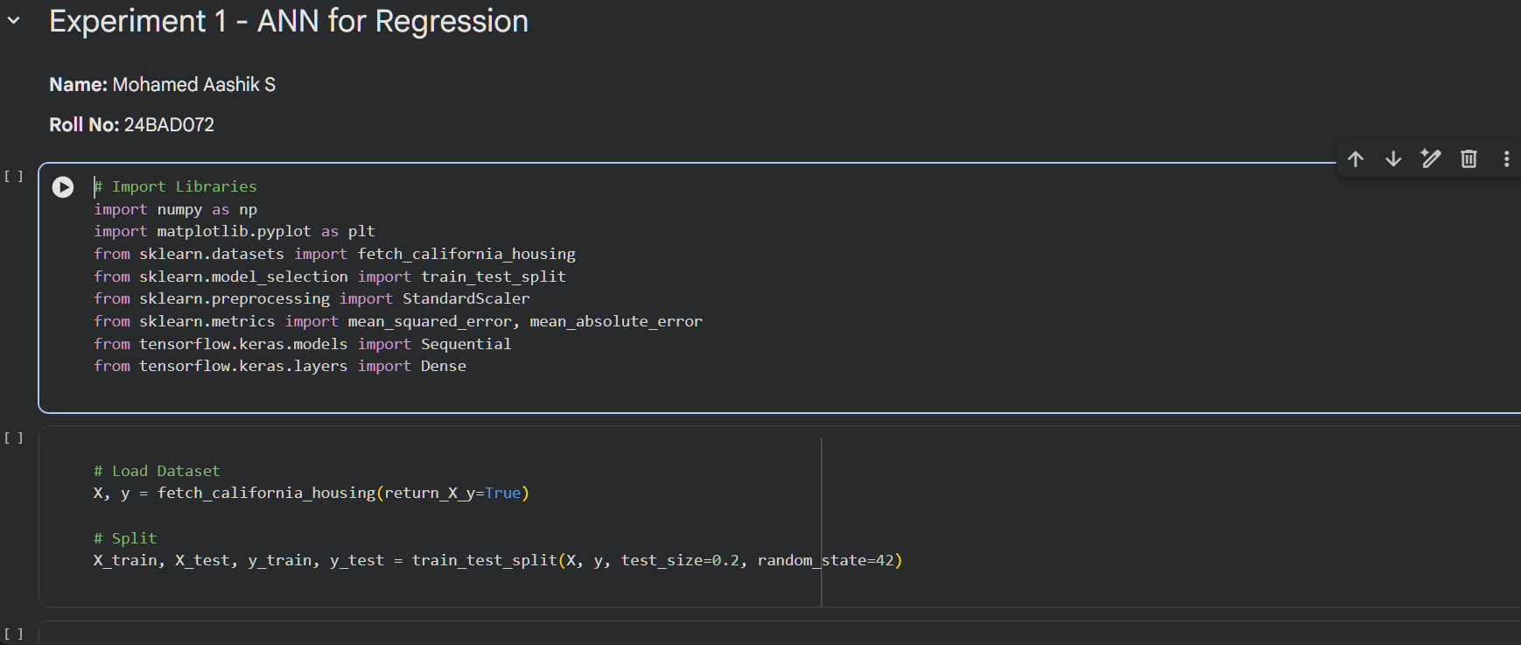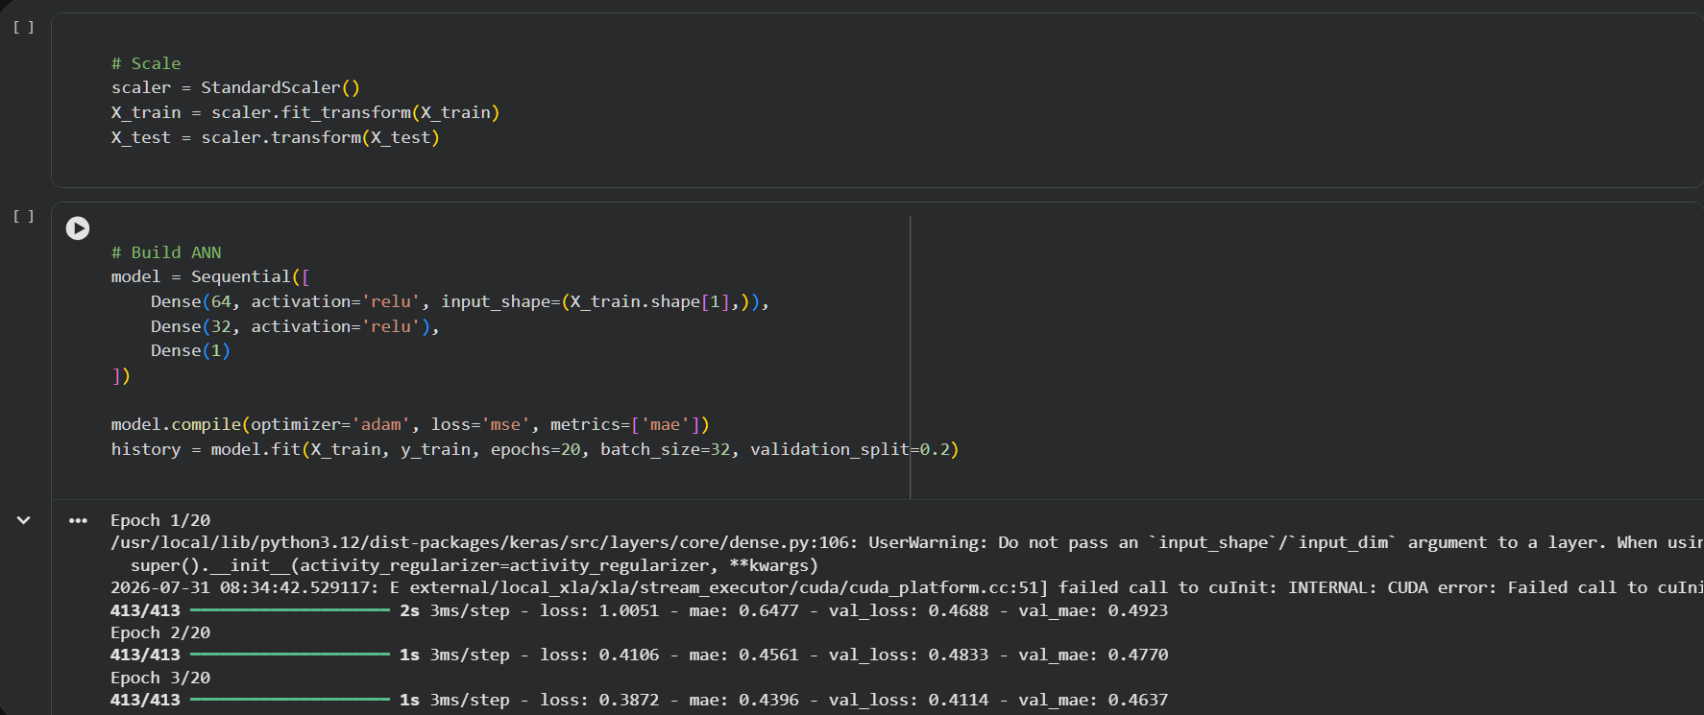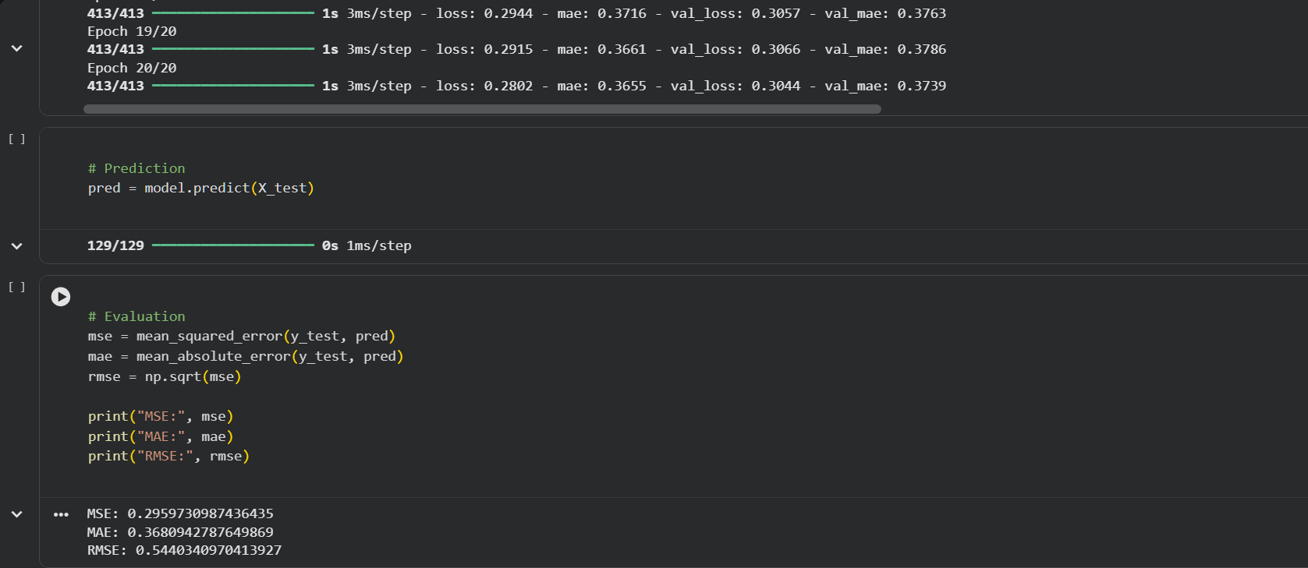
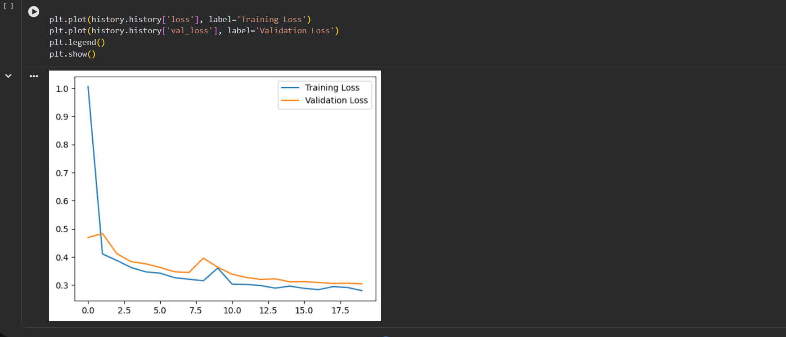

Task B – ANN FOR CLASSIFICATION
DATASET: Breast Cancer Wisconsin Dataset
SOURCE: Scikit-learn
DESCRIPTION
- Samples: 569
- Features: 30
- Classes:
  - Malignant
  - Benign

ALGORITHM
- Import libraries.
- Load Breast Cancer dataset.
- Split dataset.
- Standardize features.
- Design ANN.
- Compile model.
- Train model.
- Predict labels.
- Evaluate:
  - Accuracy
  - Precision
  - Recall
  - F1-score
  - Confusion Matrix

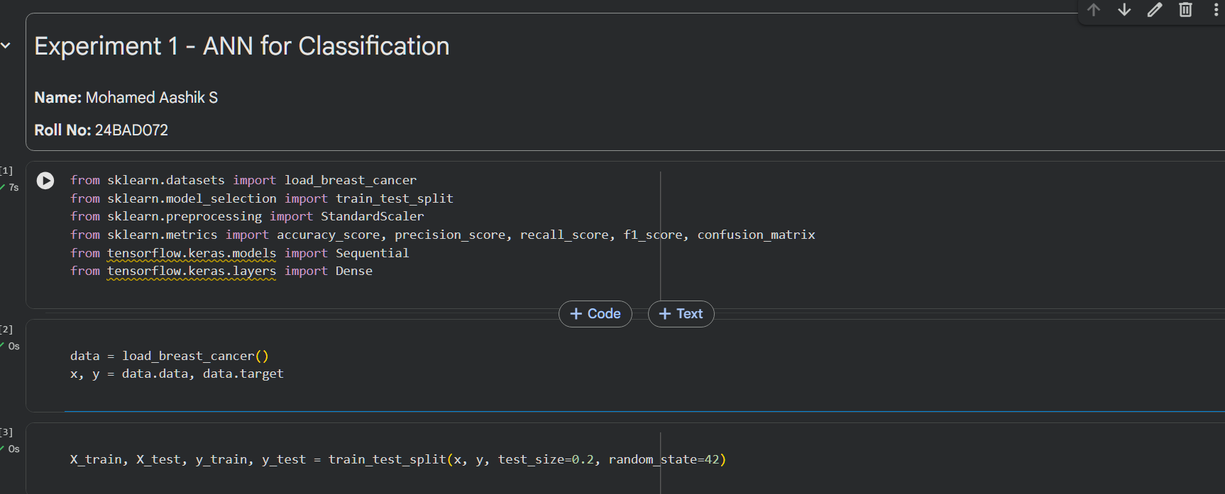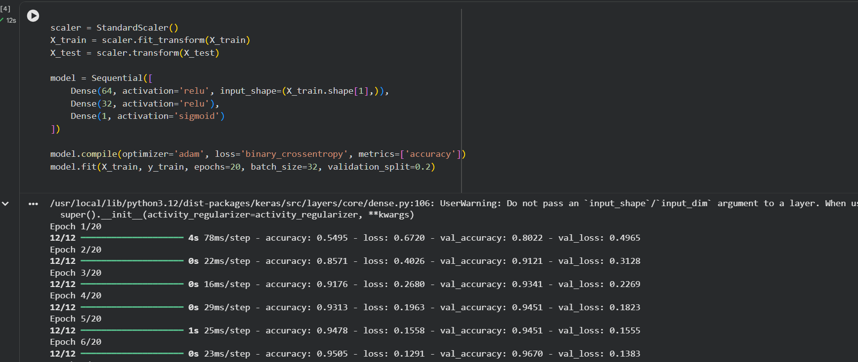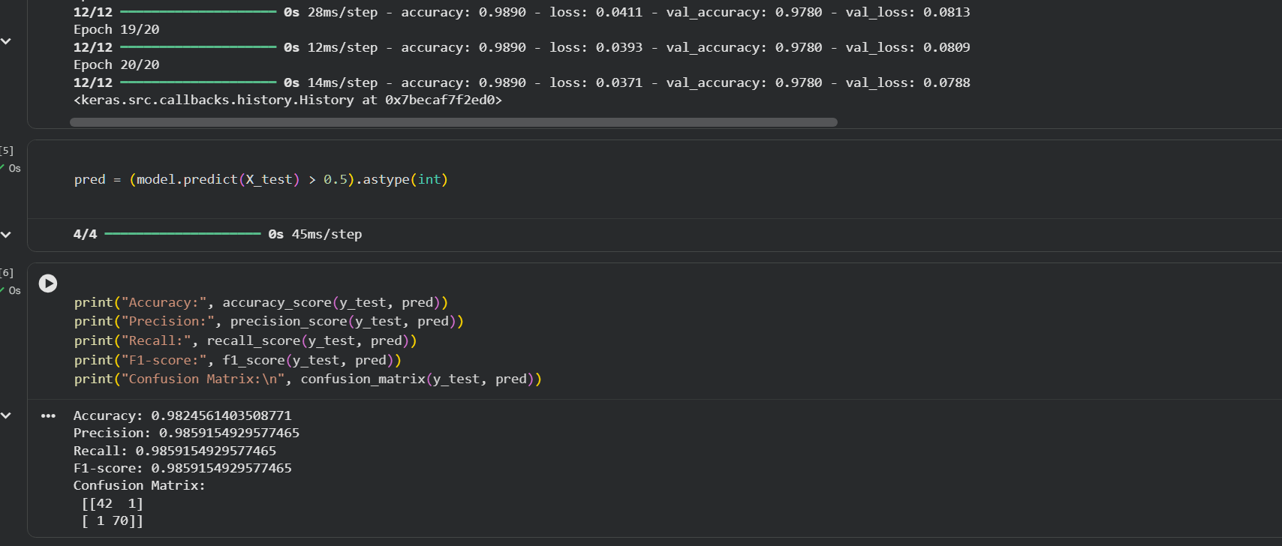

POST-LAB QUESTIONS

- Why is the Adam optimizer commonly used in ANN training?

The Adam optimizer is widely used because it combines the advantages of Momentum and RMSProp optimization techniques. It automatically adjusts the learning rate for each parameter based on previous gradients, resulting in faster and more stable convergence. Adam performs efficiently on large datasets and deep neural networks while requiring minimal hyperparameter tuning. It reduces oscillations during training and helps the model reach the optimal solution more quickly. Due to its speed, accuracy, and computational efficiency, Adam is the default optimizer in many deep learning applications.

- Compare Mean Squared Error (MSE) and Mean Absolute Error (MAE). Which metric is more sensitive to outliers?

Mean Squared Error (MSE) calculates the average of the squared differences between predicted and actual values, giving higher penalties to larger errors. Mean Absolute Error (MAE) calculates the average of the absolute differences, treating all errors equally regardless of their magnitude. Because MSE squares the error values, it becomes highly sensitive to outliers in the dataset. MAE is more robust and easier to interpret since it measures the average prediction error directly. Therefore, MSE is more sensitive to outliers, whereas MAE provides a more balanced measure of prediction error.

- Why is the sigmoid activation function used in binary classification?

The sigmoid activation function converts any real-valued input into a probability value between 0 and 1. This probability represents the likelihood that an input belongs to the positive class in a binary classification problem. A threshold value, usually 0.5, is then used to assign the final class label. The sigmoid function is smooth, differentiable, and compatible with Binary Cross-Entropy loss used during training. Hence, it is commonly used in the output layer of binary classification neural networks.

- How does increasing the number of hidden layers affect the performance of an ANN?

Increasing the number of hidden layers enables an ANN to learn more complex and hierarchical representations of the input data. Deep networks can capture intricate patterns that improve performance on challenging tasks such as image recognition and natural language processing. However, adding too many hidden layers increases computational complexity, training time, and memory usage. It may also lead to overfitting if sufficient training data and regularization techniques are not used. Therefore, the network depth should be selected carefully to balance accuracy and computational efficiency.

- Compare the evaluation metrics used for regression and classification tasks. Why are different metrics required for these problems?

Regression models are evaluated using metrics such as Mean Squared Error (MSE), Mean Absolute Error (MAE), and Root Mean Squared Error (RMSE), which measure numerical prediction errors. Classification models use Accuracy, Precision, Recall, F1-score, and Confusion Matrix to measure how correctly the model predicts class labels. Regression metrics evaluate the difference between predicted and actual continuous values, whereas classification metrics assess the correctness of categorical predictions. Since the outputs of regression and classification are fundamentally different, separate evaluation metrics are required. Choosing appropriate metrics ensures accurate assessment of model performance for the specific machine learning task.

ASSESSMENT
Description | Max Marks | Marks Awarded
Pre Lab Exercise | 5
In Lab Exercise | 10
Post Lab Exercise | 5
Viva | 10
Total | 30
Faculty Signature

